Cookbook “LazyCook”

Software Requirements Specification Document

Version: 1.0 Date: (21/09/2015)

1. **INTRODUCTION**
   1. Purpose

The purpose of this project is to make the process of cooking faster by creating extensive database of recipes. User can easily find recipes of all the dishes he can cook using ingredients available. User can add his own recipes and delete them.

* 1. Scope

Software product “LazyCook” is a kind of Desktop cookbooks. That is why it should perform such functions as storing recipes in database, creating new recipes and finding them. This software product will be helpful for both professional cookers and users with small skills in this area.

* 1. Definitions, Acronyms, and Abbreviations

DB – database.

PC – personal computer.

SQL – structured query language.

1. **THE OVERALL DESCRIPTION**

The following subsections describe the general factors that affect the product and its requirements.

* 1. Product Perspective

There is a great amount of cookbooks today, both in paper and electronic variants. Electronic cookbooks can be divided into Web cookbooks and Desktop cookbooks. The number of Web cookbooks is much bigger because it is has larger library of recipes. But Desktop Cookbooks are also popular, especially in situations, where there is no ability to find recipe in Web. Software product “LazyCooker” was created to solve this problem. Of course, it has many analogues. The main problem is that users have no chance to add thein own recipes. “LazyCooker” is intended to edit these omission.

* + 1. Software Interfaces

Qt Creator 4.3.2

SQLite Browser

* + 1. User Interface

The system interacts with user through GUI. It does not need specific requirements.

|  |  |
| --- | --- |
| User’s action | Reaction |
| Double-click on the icon of the program | Open the start window |
| Click on the button “Add new recipe” | Open a new window with fields for entry of information |
| Correctly type information and click on the button “Add” | Return to the start window. Recipe successfully added to the DB |
| Click on the button “Delete recipe” | Delete recipe from the DB |
| Search for the recipe by name\part of name | Return all recipes with typed combination in its name |
| Search for the recipe by ingredients | Return all recipes with typed combination in its ingredients |
| Search for the recipe by type | Return all recipes with typed combination in its type |
| Search for the recipe by author | Return all recipes with typed combination in its author |
| Click on the cross icon | Close the window |

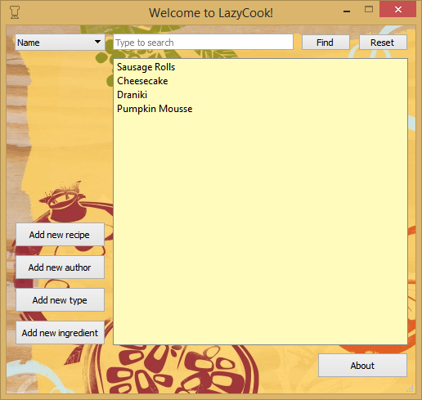

Picture 1 – SatrtPage

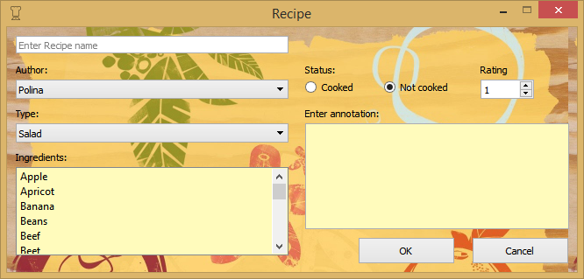

Picture 2 – AddRecipe

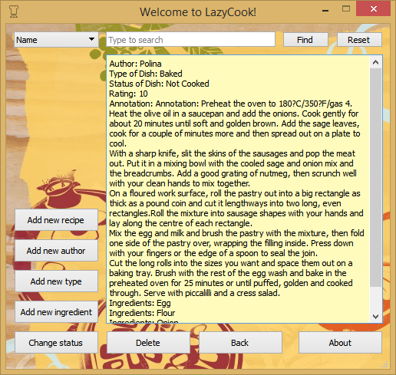

Picture 3 – AboutRecipe

* 1. Product Functions

The software performs following functions:

1. Adding new recipes to the database.
2. Deleting recipes from database.
3. Searching for recipes by name.
4. Searching for recipes by ingredients.
5. Searching for recipes by author.
6. Searching for recipes by type.
7. Reading information about recipe.
   1. User Characteristics

Software product “LazyCooker” is oriented on users from all sectors of society. It has intuitive interface and the only thing the user should know is English language. From technical experience, it is necessary to distinguish using PC on middle level.

* 1. Assumptions and Dependencies

Operating system – Windows 7/8/10/XP.

1. **SPECIFIC REQUIREMENTS**
   1. Functional Requirements

Application's function set is represented by the following list of abilities:

- addinng new recipes.

- changing status of recipes(Cooked/ Not cooked).

- deleting recipes.

- setting ratings to recipes.

- finding recipes by name.

- finding recipes by ingredients.

- finding recipes by type.

- finding recipes by author.

* 1. Performance Requirements

Static numerical requirements:

1. The number of simultaneous users to be supported – 1.
2. 95% of the transactions shall be processed in less than 1 second rather than, an operator shall not have to wait for the transaction to complete.
   1. Software System Attributes
      1. Reliability

Such attribute as reliability is one of the most important because it gives guarantee that software product stably works under certain conditions. It includes:

1. The system works equally stable under a variety of operating systems.
2. The system returns correct output data corresponding to input data.
3. The time of processing the request do not exceed 1 second.
   * 1. Availability
4. The requirements for system recovery from a failure: the system shall allow users to restart the application after failure without losing the last saved information.
5. The program is available for all users of PC.
   * 1. Security

This software product is open source. It does not need a high level of security. The only type of protecting data is to restrict communications between some important areas of program and check data integrity for critical variables.

* + 1. Portability

The software has not very high portability becuse it works under Windows OS.